# Azure Cloud

1. Create an Azure account – Go to <https://account.microsoft.com>
2. If you do not have an account , it will redirect you to sign in or sign up page
3. Sign up and create the account.

# Download CLI(Azure CLI)

1. Download from <https://docs.microsoft.com/en-us/cli/azure/install-azure-cli-windows?view=azure-cli-latest>

2. Run the MSI installer, it should install Azure cli on your system

3. Login to your account from Azure cli using the below command

## Create an Azure Container Registry (https://portal.azure.com)

1. Login - az login -u <saket.kashyap@outlook.com> -p <password>
2. az group create --name saketregistry --location eastus

* creates a resource group called saketregistry

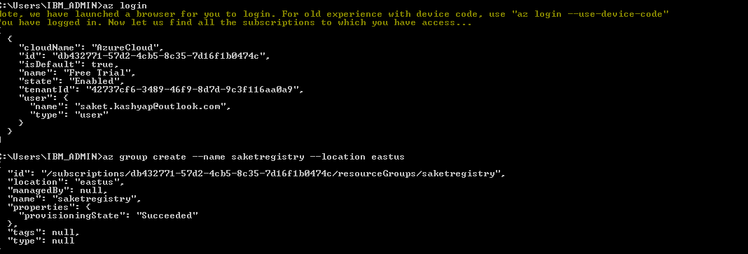

1. Now create a container registry within the resource group

az acr create --resource-group saketregistry --name saketcontainerregistry --sku Basic

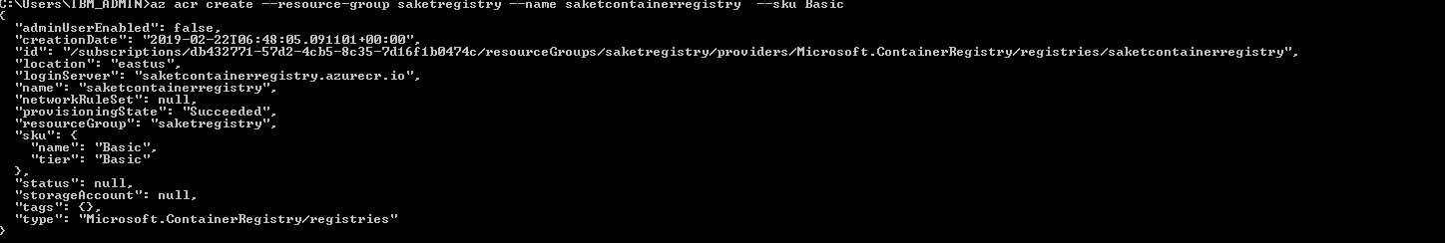

Additionally you can also login to azure portal to see your resources within the resource group.

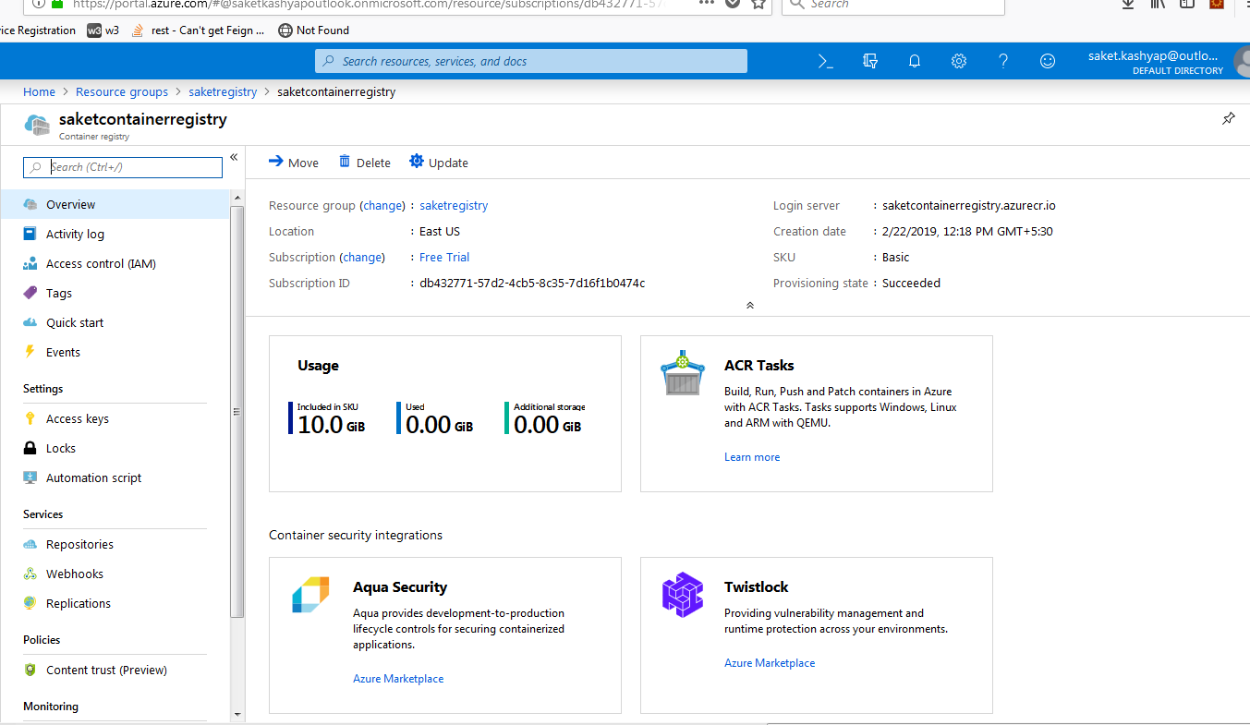

1. Login to your container registry

* az acr login --name saketcontainerregistry

1. Now list all the docker images that you have – docker images

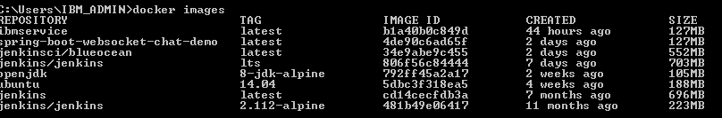

1. Choose the image that you want to push to the container registry – (ibmservice)
2. Any image that you wish to use with ACR(Azure container registry) .The image needs to be tagged with the login server address of your registry. This tag is used for routing when pushing container images to an image registry.
3. Now tag the image you wish to push to ACR using –

docker tag ibmservice saketcontainerregistry.azurecr.io/ibmservice:v1

1. And push the image to ACR

docker push saketcontainerregistry.azurecr.io/ibmservice:v1

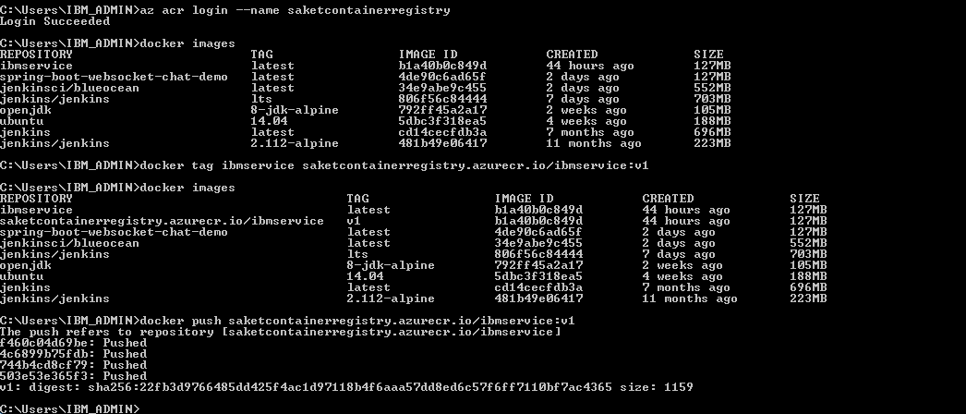

1. To verify list the images in the ACR

* az acr repository list --name saketcontainerregistry --output table

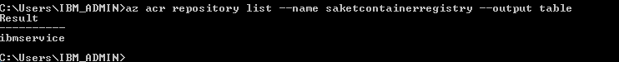

* additionaly you can verify this on the portal as well

1. Setup access key for your ACR – click on enable in the screenshot below

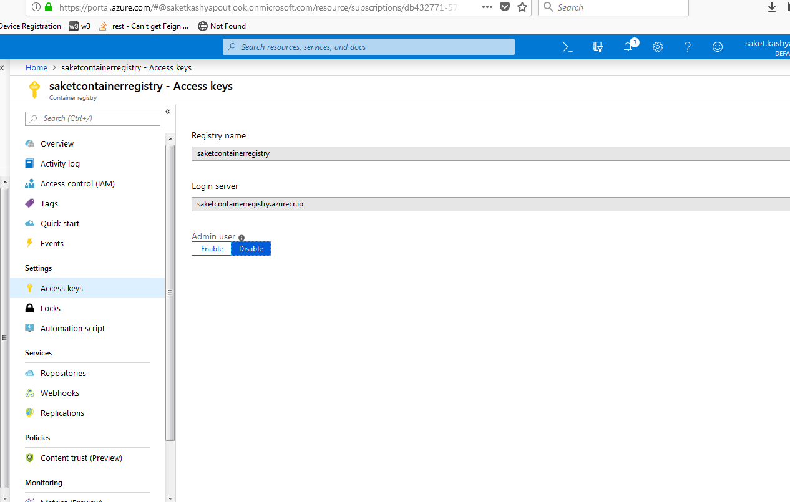

* If enabled, you can use the registry name as username and admin access key as the password to login through docker

1. Check the portal for the new image that was pushed

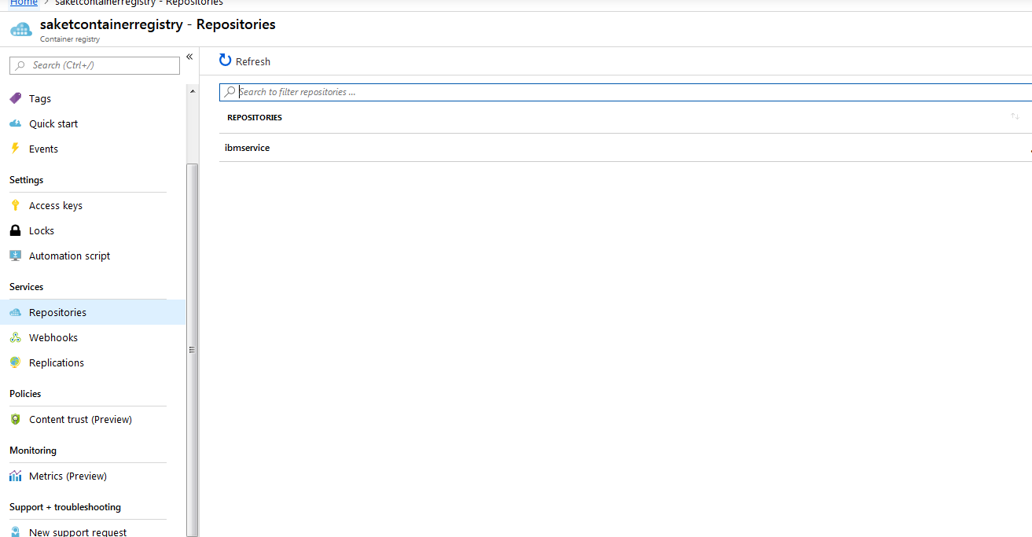

1. To see the tag of the image pushed to the container registry

az acr repository show-tags --name saketcontainerregistry --repository ibmservice --output table

